## Synopsis

Area of Project: Internet of Things

Area of Project:………………………………………………………………...……………

Sponsored By (If applicable): Copper Cloud Pvt. Ltd

Name External Guide (If applicable): Abhijeet Deogirikar ………………….…………………..

Project Group No: 07

Internal Guide: Prof. Maithili Andhare

**Project Co-Coordinator**

**Dr. Rahul Mapari**

**Head of Dept.**

## Project Title:

## Smart Building

**Name of the student Roll no**

1) Tejveer Anand 68

2)Siddhant Jain 27

3)Sourabh Upare 71

## Project Title: Smart Building

**Abstract: -**

There is an increasing interest in the Internet of Things (IoT) enabled smart buildings. The main

question is: what are the key challenges, which must be addressed to effectively manage and analyze the big

data for IoT enabled smart buildings. There is a need for the systematic literature review to understand the

challenges and the solutions to overcome such challenges. Using the SLR approach, 30 relevant studies were

identified and reviewed in this paper. The data from these selected studies were extracted to identify the

challenges and relevant solutions.

There is an increasing interest in the Internet of Things (IoT) enabled smart buildings. The main

question is: what are the key challenges, which must be addressed to effectively manage and analyze the big

data for IoT enabled smart buildings. There is a need for the systematic literature review to understand the

challenges and the solutions to overcome such challenges. Using the SLR approach, 30 relevant studies were

identified and reviewed in this paper. The data from these selected studies were extracted to identify the

challenges and relevant solutions.

There is an increasing interest in the Internet of Things (IoT) enabled smart buildings. The main

question is: what are the key challenges, which must be addressed to effectively manage and analyze the big

data for IoT enabled smart buildings. There is a need for the systematic literature review to understand the

challenges and the solutions to overcome such challenges. Using the SLR approach, 30 relevant studies were

identified and reviewed in this paper. The data from these selected studies were extracted to identify the

challenges and relevant solutions

There is an increasing interest in the Internet of Things (IoT) enabled smart buildings. The main question is: what are the key challenges, which must be addressed to effectively manage and analyze the big data for IoT enabled smart buildings using the Agile methodology. Agile methods or Agile processes generally promote a disciplined project management process that encourages frequent inspection and adaptation, a leadership philosophy that encourages teamwork, self-organization and accountability, a set of engineering best practices intended to allow for rapid delivery of high-quality software, and a business approach that aligns development with customer needs and company goals. Our current research is focused on developing such framework using a model driven architecture using an agile approach.

**Introduction: -**

There is an increasing interest in using IoT devices for making buildings smarter and efficient. For instance, a significant amount of energy is being consumed by buildings. The need for energy efficiency in buildings is critical, and one of the objectives of a “smart building” is to monitor, reduce and manage building energy consumption without compromising the occupant comfort and operational efficiency. Hence, smart buildings can employ different types of IoT sensors in mechanical systems which make these systems more intelligent. A huge amount of data is generated from the embedded IoT sensors and their associated controllers mounted within the smart buildings. This IoT enabled smart building data can be extracted, filtered, analyzed and used for smart building analytics. It is clear that there is a growing interest in smart buildings and data management and analytics. However, there is a dire need to identify the challenges as well as the solutions to overcome those challenges in this domain.

**Aim:**

To monitor, reduce and manage building energy consumption without compromising the occupant comfort and operational efficiency.

**Objectives:**

1. **Control lights using motion sensors.**
2. **Measure energy consumption.**
3. **Real time analysis of data on monitor.**

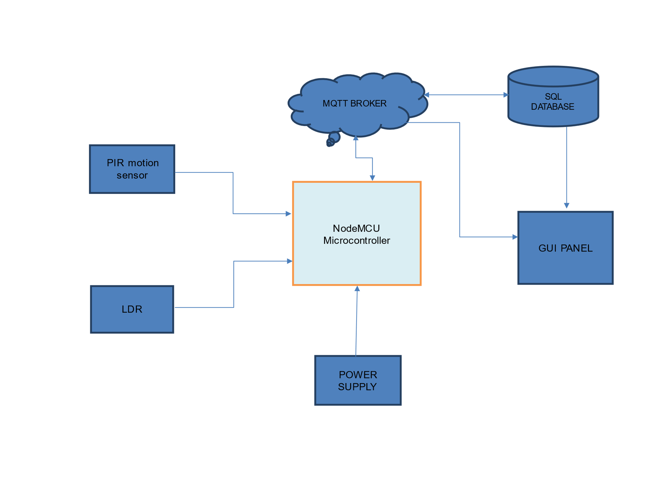

Start

ESP8266 is connected to Wi-Fi

Light intensity sensor and motion sensor data is collected

**NO**

**NO**

Light> Threshold

Motion is Detected

**YES YES**

Lights on

End

**Explanation: -**

* **Microcontroller**: - The microcontroller will be integrated with Wi-Fi module which will be connected to Node red through MQTT on Cloud. Node Red is a IOT integration tool and it compares the data available in SQL database and data analysis is generated on a GUI panel.
* **LDR sensor**: - An LDR or light dependent resistor is also known as photo resistor, photocell, photo conductor. When the light falls on the resistor, then the resistance changes.
* **Motion Sensor: -** A motion sensor is a device that notices moving objects, mainly people. A motion sensor is frequently incorporated as a component of a system that routinely performs a task or else alert a user of motion in a region.
* **MQTT Broker**: - An MQTT broker is a server that receives all messages from the clients and then routes the messages to the appropriate destination clients.
* **SQL Database**: - SQL is Structured Query Language, which is a computer language for storing, manipulating and retrieving data stored in a relational database.

**Advantages: -**

1. Full control over all applications using a single device.
2. Improve energy efficiency of building.
3. Increase in convenience.

**Disadvantages: -**

1. Reliable internet connection is crucial.
2. Significant installation costs.
3. Compatibility issues between devices.

**Applications: -**

1. Can be used in places like household, institutions, industries.
2. Smart Parking, Lighting and Infrastructure.
3. Promotes Green buildings.
4. Energy conservation.

**References: -**

1. Olivier Debauche and Yahya Moussaoui, “Internet of Things Learning: A practical Case for Smart Building automation”. IEEE 2020.
2. Anirudh Ramasami and Surya Varanasi, “Smart Building Automation using Internet of Things”. IRJET 2019.
3. M. R. Bashir and A. Q. Gill, “Towards an IoT Data Analysis Framework: Smart Building System”. 2016.